**MACHINE LEARNING-1**

**ASSIGNMENT 07**

**ANAGHA ASHOK**

**21BDA50**

**QUESTION 2**

**What is Stride, Padding & Pooling? Explain with an example**.

1. **What is Stride (Machine Learning)?**

Stride is a component of [convolutional neural networks](https://deepai.org/machine-learning-glossary-and-terms/convolutional-neural-network), or [neural networks](https://deepai.org/machine-learning-glossary-and-terms/neural-network) tuned for the compression of images and video data. Stride is a parameter of the neural network's filter that modifies the amount of movement over the image or video.

For example, if a neural network's stride is set to 1, the filter will move one pixel, or unit, at a time. The size of the filter affects the encoded output volume, so stride is often set to a whole integer, rather than a fraction or decimal.

**How does Stride work?**

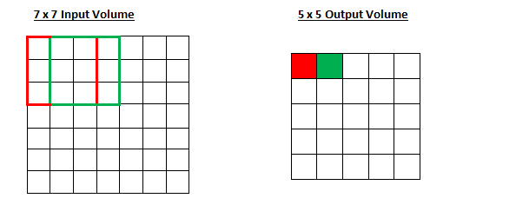

[Source](https://adeshpande3.github.io/A-Beginner%27s-Guide-To-Understanding-Convolutional-Neural-Networks-Part-2/)

Imagine a convolutional neural network is taking an image and analysing the content. If the filter size is 3x3 pixels, the contained nine pixels will be converted down to 1 pixel in the output layer. Naturally, as the stride, or movement, is increased, the resulting output will be smaller. Stride is a parameter that works in conjunction with [padding](https://deepai.org/machine-learning-glossary-and-terms/padding), the feature that adds blank, or empty pixels to the frame of the image to allow for a minimized reduction of size in the output layer. Roughly, it is a way of increasing the size of an image, to counteract the fact that stride reduces the size. Padding and stride are the foundational parameters of any convolutional neural network.

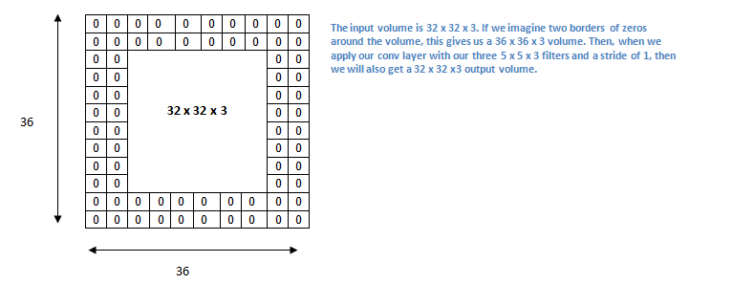

[Source](https://adeshpande3.github.io/A-Beginner%27s-Guide-To-Understanding-Convolutional-Neural-Networks-Part-2/)

## What is Padding in Machine Learning?

Padding is a term relevant to [convolutional neural networks](https://deepai.org/machine-learning-glossary-and-terms/convolutional-neural-network) as it refers to the amount of pixels added to an image when it is being processed by the kernel of a CNN. For example, if the padding in a CNN is set to zero, then every pixel value that is added will be of value zero. If, however, the zero padding is set to one, there will be a one pixel border added to the image with a pixel value of zero.

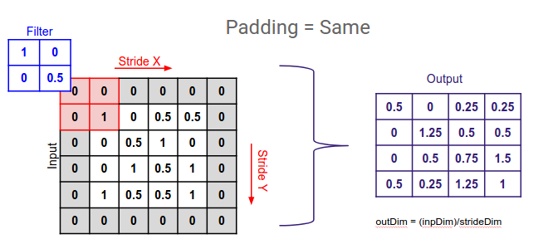

[Source](https://medium.com/@ayeshmanthaperera/what-is-padding-in-cnns-71b21fb0dd7)

# **What is Pooling in a Convolutional Neural Network (CNN)**

**Pooling in convolutional neural networks is a technique for generalizing features extracted by convolutional filters and helping the network recognize features independent of their location in the image.**

The pooling operation involves sliding a two-dimensional filter over each channel of feature map and summarising the features lying within the region covered by the filter.   
For a feature map having dimensions **nh x nw x nc**, the dimensions of output obtained after a pooling layer is 

**(nh - f + 1) / s x (nw - f + 1)/s x nc**

where,

-> **nh -** height of feature map

-> **nw -** width of feature map

-> **nc -** number of channels in the feature map

-> **f -** size of filter

-> **s -** stride length

A common CNN model architecture is to have a number of convolution and pooling layers stacked one after the other.

**QUESTION 4**

1. **What is overfitting? How to overcome overfitting in an ML model?**

A statistical model is said to be overfitted when we feed it a lot more data than necessary. To make it relatable, imagine trying to fit into oversized apparel.

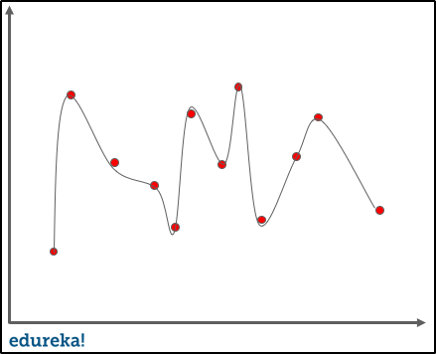

When a model fits more data than it actually needs, it starts catching the noisy data and inaccurate values in the data. As a result, the efficiency and accuracy of the model decrease.

Example: Let us consider we want to predict if a soccer player will land a slot in a tier 1 football club based on his/her current performance in the tier 2 league.

Now imagine, we train and fit the model with 10,000 such players with outcomes. When we try to predict the outcome on the original data set, let us say we got a 99% accuracy. But the accuracy on a different data set comes around 50 percent. This means the model does not generalize well from our training data and unseen data.

This is what overfitting looks like. It is a very common problem in Machine Learning and even data science.

**Handling Overfitting:**

There are a number of techniques that machine learning researchers can use to mitigate overfitting. These include :

**Cross-validation**

This is done by splitting your dataset into ‘test’ data and ‘train’ data. Build the model using the ‘train’ set. The ‘test’ set is used for in-time validation. This way you know what the expected output is and you will easily be able to judge the accuracy of your model.

**Regularization**

This is a form of regression, that regularizes or shrinks the coefficient estimates towards zero. This technique discourages learning a more complex model.

**Early stopping**

When training a learner with an iterative method, you stop the training process before the final iteration. This prevents the model from memorizing the dataset.

**Pruning**

This technique applies to decision trees.

Pre-pruning: Stop ‘growing’ the tree earlier before it perfectly classifies the training set.

Post-pruning: Allows the tree to ‘grow’, perfectly classify the training set and then post prune the tree.

**Dropout**

This is a technique where randomly selected neurons are ignored during training.